**CHAPTER - 1**

**Introduction**

**1.1 Overview of JavaScript**

JavaScript is a high-level, dynamic, and interpreted programming language that is widely used for web development. It was created in 1995 by Brendan Eich and has since become an essential technology for building interactive and dynamic web applications. JavaScript allows developers to implement complex features on web pages, such as interactive forms, animations, and real-time updates.

**1.2 Importance of JavaScript in Web Development**

JavaScript is crucial in web development as it enables client-side scripting, allowing for a more responsive user experience. It works alongside HTML and CSS to create rich web applications. With the rise of frameworks and libraries like React, Angular, and Vue.js, JavaScript has become even more powerful, enabling developers to build single-page applications (SPAs) and progressive web applications (PWAs).



Fig 1.2 Javascript logo

**1.3 JavaScript Engines**

JavaScript engines are programs that execute JavaScript code. The most popular engines include Google’s V8 (used in Chrome and Node.js), Mozilla’s SpiderMonkey, and Microsoft’s Chakra. These engines convert JavaScript code into machine code, optimizing performance and enabling features like Just-In-Time (JIT) compilation.

**1.4 JavaScript Frameworks and Libraries**

JavaScript frameworks and libraries provide pre-written code to simplify development tasks. Frameworks like Angular and React offer structured ways to build applications, while libraries like jQuery simplify DOM manipulation and event handling. These tools enhance productivity and maintainability in web development.

**1.5 Development Tools and Environments**

Development tools for JavaScript include code editors (like Visual Studio Code), version control systems (like Git), and debugging tools (like Chrome DevTools). These tools help developers write, test, and maintain their code efficiently.

**CHAPTER – 2**

**JavaScript Fundamentals**

### **2.1 Variables and Data Types**

In JavaScript, variables are used to store data values. There are three primary ways to declare variables: var, let, and const. var is function-scoped, while let and const are block-scoped, with const being used for variables that cannot be reassigned. JavaScript is dynamically typed, meaning the type of a variable is determined at runtime. Common data types include:

* **Primitive types**: String, Number, Boolean, Undefined, Null, Symbol, and BigInt.
* **Reference types**: Objects, Arrays, and Functions, which store collections of data or more complex structures.

### **2.2 Operators**

JavaScript provides a variety of operators to manipulate data. These include:

* **Arithmetic operators** (+, -, *, /, %): Used for basic mathematical operations.
* **Comparison operators** (==, ===, !=, >, <, >=, <=): Used to compare values, with === checking for strict equality.
* **Logical operators** (&&, ||, !): Used to perform logical operations, returning Boolean values.
* **Assignment operators** (=, +=, -=, *=, /=): Used to assign values to variables.
* **Ternary operator** (condition ? expr1 : expr2): A shorthand for an if-else statement.

### **2.3 Control Structures**

Control structures in JavaScript manage the flow of execution based on conditions and iterations. These include:

* **Conditional statements**: if, else if, else, and switch are used to execute code based on specific conditions.
* **Loops**: for, while, and do-while loops are used to execute a block of code multiple times until a condition is met.
* **Break and continue**: Control the flow within loops, allowing you to exit or skip an iteration.

### **2.4 Functions**

Functions in JavaScript are blocks of reusable code that can take inputs (parameters) and return outputs (values). There are several ways to declare functions:

* **Function declarations**: function myFunction() {}.
* **Function expressions**: A function can also be assigned to a variable, e.g., const myFunc = function() {}.
* **Arrow functions**: A concise syntax, e.g., const myFunc = () => {}. Functions allow for modular code, improving readability and maintainability. They can also have closures, meaning they retain access to variables from their outer scope even after the function has returned.

### **2.5 Scope and Hoisting**

**Scope** refers to the context in which a variable is accessible. In JavaScript, variables can have **global scope** (accessible everywhere) or **local scope** (accessible only within a specific function or block).

* **Lexical scoping** means that the scope is determined by where the variable is declared in the code.
* **Hoisting** is JavaScript's behavior of moving declarations to the top of their scope before code execution. For var declarations, only the declaration is hoisted, not the initialization, while let and const are hoisted but not initialized.

### **2.6 Error Handling**

Error handling in JavaScript is done using the try, catch, and finally blocks. The try block contains code that might throw an error, while catch handles the error if it occurs. The finally block executes code after the try-catch, regardless of whether an error occurred. JavaScript also provides built-in error objects such as Error, TypeError, and ReferenceError. Custom errors can be created using throw to throw exceptions when certain conditions are met.

**CHAPTER – 3**

**Asynchronous JavaScript**

### **3.1 Callbacks**

A **callback** is a function that is passed as an argument to another function and is executed once the other function finishes its task. Callbacks are commonly used for handling asynchronous operations, such as reading files or making network requests. While they are essential for asynchronous programming, callbacks can lead to **callback hell**—a situation where multiple nested callbacks become difficult to manage and read. To avoid this, developers often use Promises or async/await.

### **3.2 Promises**

A **Promise** is an object that represents the eventual completion (or failure) of an asynchronous operation and its resulting value. A Promise can be in one of three states:

* **Pending**: The operation is still in progress.
* **Resolved**: The operation completed successfully, with a result.
* **Rejected**: The operation failed, with an error. Promises allow for cleaner handling of asynchronous code using .then() for handling success and .catch() for errors. Promises help avoid the "callback hell" by enabling chaining of operations.

### **3.3 Async/Await**

**Async/Await** is syntactic sugar built on top of Promises, designed to simplify asynchronous programming. An **async** function automatically returns a Promise, and within this function, **await** can be used to pause execution until the Promise is resolved. This makes asynchronous code look and behave like synchronous code, improving readability and maintainability. await can only be used inside an async function, and it helps avoid chaining Promises, making the code flow more naturally.

### **3.4 Fetch API**

The **Fetch API** is a modern way to make asynchronous HTTP requests in JavaScript. It is based on Promises and provides a cleaner, more flexible alternative to older methods like XMLHttpRequest. The fetch() function allows you to make requests to a server and retrieve resources such as JSON, text, or images. The basic syntax is fetch(url).then(response => response.json()). You can also handle errors using .catch() or by using async/await syntax. The Fetch API simplifies handling HTTP requests and responses, including the ability to work with headers, credentials, and more.

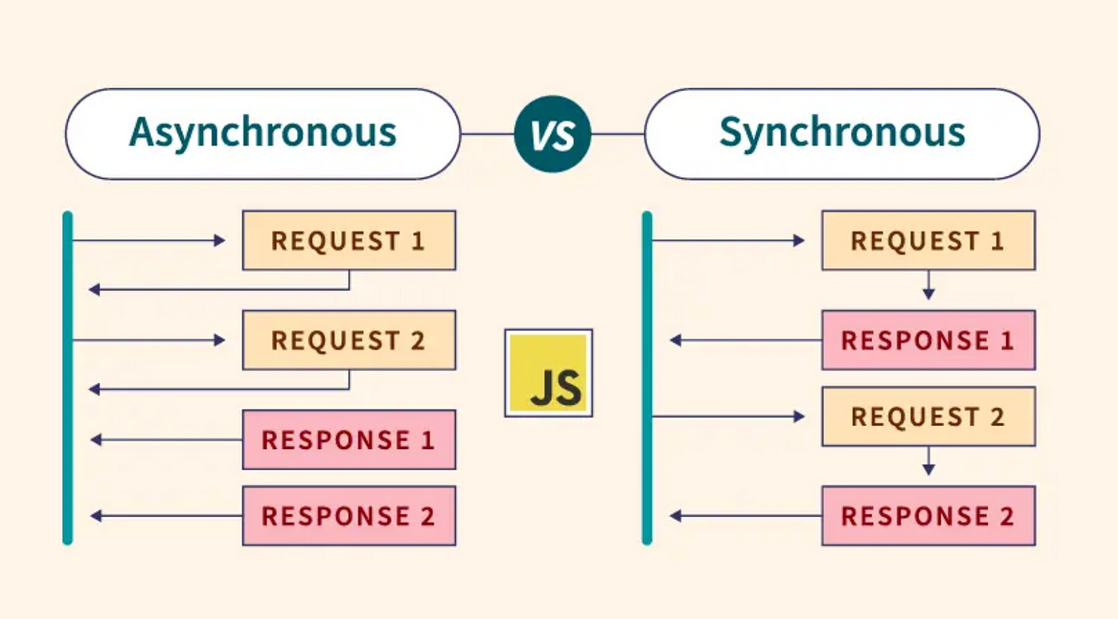

Fig3.4 Async & Sync JS

**CHAPTER – 4**

**Document Object Model (DOM)**

### **4.1 Understanding the DOM**

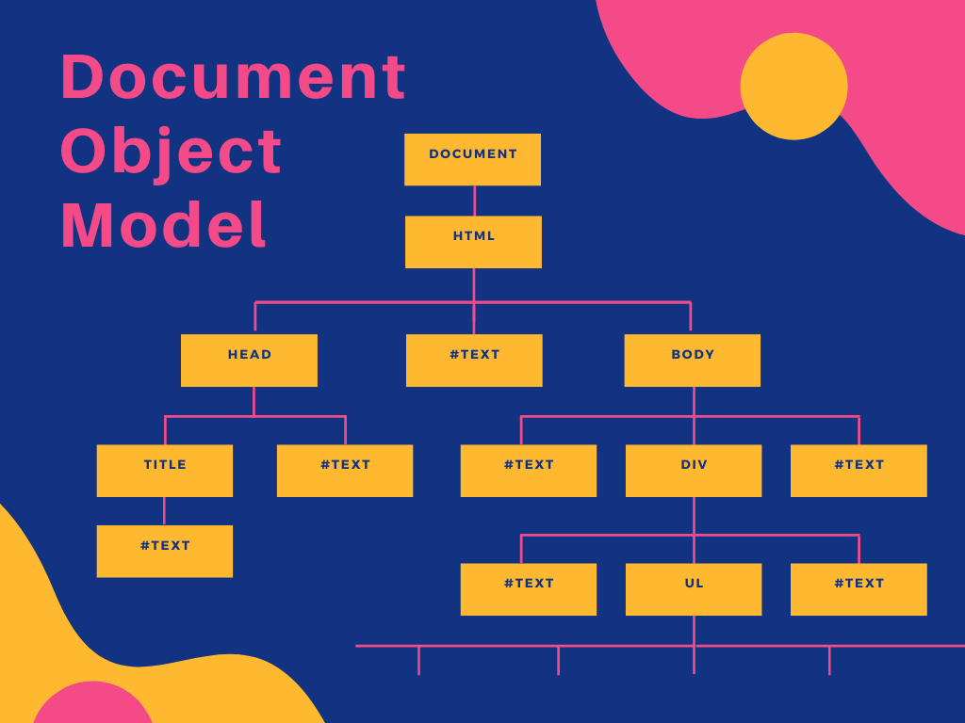The **Document Object Model (DOM)** is a programming interface for web documents. It represents the structure of a webpage as a tree of objects, where each object corresponds to a part of the page (like elements, attributes, or text). The DOM allows JavaScript to interact with and manipulate the content, structure, and style of HTML documents. With the DOM, developers can add, remove, and modify elements dynamically, enabling the creation of interactive and dynamic web pages. The DOM is a language-independent interface, meaning it can be accessed using different programming languages, though JavaScript is the most common.

Fig4.1 Document Object Model

### **4.2 DOM Manipulation**

**DOM Manipulation** refers to the ability to modify the structure, content, and style of a webpage through JavaScript. Common DOM manipulation methods include:

* **Selecting elements**: Methods like document.getElementById(), document.querySelector(), and document.querySelectorAll() are used to access elements in the document.
* **Modifying content**: The innerHTML, textContent, and value properties are used to change the content inside elements, like updating the text or HTML of a page.
* **Changing attributes**: The setAttribute() and getAttribute() methods allow you to modify element attributes like src, href, class, etc.
* **Manipulating styles**: You can change inline styles using the style property or add/remove CSS classes with classList.add(), classList.remove(), etc.
* **Adding/removing elements**: Methods like appendChild(), removeChild(), and createElement() let you dynamically add or remove elements from the DOM.

### **4.3 Event Handling**

**Event Handling** in JavaScript allows you to respond to user interactions and other events that occur in the browser. Events include actions like clicks, keypresses, form submissions, and page loads. To handle events, you can use event listeners with methods like addEventListener():

* **Event types**: Examples of events include click, submit, keydown, mousemove, and more.
* **Event listeners**: By using addEventListener(), you can listen for specific events and execute a callback function when the event occurs.
* **Event bubbling**: Events propagate through the DOM tree from the target element to the root. This allows you to handle events at a higher level (event delegation) by attaching a listener to a parent element instead of individual child elements.

### **4.4 Working with Forms**

**Working with Forms** in JavaScript involves handling user input, validating form data, and submitting forms dynamically. JavaScript can interact with form elements like text inputs, radio buttons, checkboxes, and dropdowns using the DOM.

* **Form elements**: You can access form elements through document.forms, document.getElementById(), or document.querySelector().
* **Getting input values**: The value property of form elements (like <input>, <select>, and <textarea>) is used to get the user’s input.
* **Form validation**: JavaScript can be used to check if a form is filled out correctly before submitting it, using methods like checkValidity() and custom validation logic.
* **Submitting forms**: You can handle form submissions using submit() or by listening for the submit event and preventing the default action with preventDefault() to validate the form data first.

**CHAPTER – 5**

**Advanced JavaScript Concepts**

### **5.1 Closures**

A **closure** is a function that "remembers" its lexical scope, even when the function is executed outside that scope. This means a closure can access variables from its outer function even after the outer function has finished executing. Closures are useful for data encapsulation, creating private variables, and maintaining state across multiple function calls. They are often used in callback functions, event handlers, and for creating factory functions or modules.

Example:

|  |
| --- |
| **function outer() {**  **let counter = 0;**  **return function inner() {**  **counter++;**  **console.log(counter);**  **};**  **}**  **const increment = outer();**  **increment(); // 1**  **increment(); // 2** |

In this example, inner forms a closure over the counter variable, allowing it to persist across function calls.

### **5.2 Modules**

**Modules** in JavaScript allow you to break your code into smaller, reusable pieces, promoting better organization and maintainability. JavaScript modules can export variables, functions, or objects from one file and import them into another. The ES6 import and export syntax enables modular development:

* **Exporting**: You can export functions, objects, or variables using export.

|  |
| --- |
| **export function myFunction() { ... }**  **export const myVariable = ...;** |

* **Importing**: You can import the exports of another module using import.

**import { myFunction } from './myModule.js';**

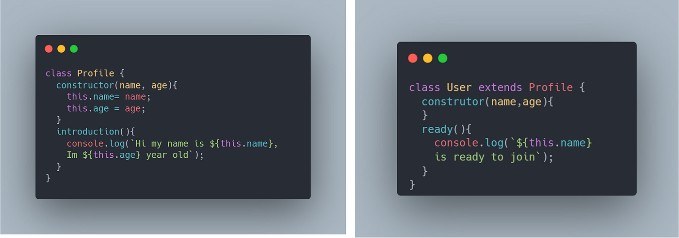Modules help in avoiding global namespace pollution, making code more maintainable and scalable. They can also improve code reusability and testing.

Fig 5.2 Advance Module

### **5.3 IIFE (Immediately Invoked Function Expressions)**

An **Immediately Invoked Function Expression (IIFE)** is a function that is defined and executed immediately after its creation. This is typically used to create a local scope, avoiding polluting the global scope with temporary variables. IIFEs are commonly used for encapsulating code and creating private variables. IIFEs are written using function expressions, which are then immediately executed by appending parentheses.

Example:

|  |
| --- |
| **(function() {**  **let privateVar = "I am private!";**  **console.log(privateVar);**  **})();** |

In this example, privateVar is only accessible inside the IIFE, helping to avoid global variable conflicts.

### **5.4 Functional Programming Concepts**

**Functional Programming (FP)** is a programming paradigm that treats computation as the evaluation of mathematical functions and avoids changing-state and mutable data. JavaScript supports functional programming concepts, which focus on functions as first-class citizens and immutability. Key concepts in functional programming include:

* **Pure Functions**: Functions that always return the same output for the same input and have no side effects.
* **Higher-Order Functions**: Functions that can take other functions as arguments or return functions as results.
* **Immutability**: Avoiding changes to existing data, instead creating new data from the old.
* **First-Class Functions**: Functions can be assigned to variables, passed as arguments, and returned from other functions.
* **Map, Reduce, Filter**: These array methods are commonly used in functional programming to process collections without using loops or mutation.

Example:

|  |
| --- |
| **const numbers = [1, 2, 3, 4];**  **const squaredNumbers = numbers.map(num => num * num);** |

This code uses the map function, a higher-order function, to apply a transformation to an array without mutating the original array.

**CHAPTER – 6**

**JavaScript in Web Development**

### **6.1 Integrating JavaScript with HTML and CSS**

JavaScript can be seamlessly integrated with HTML and CSS to create interactive and dynamic web pages:

* **HTML Integration**: JavaScript can manipulate HTML elements through the DOM. It can be embedded directly in HTML using <script> tags or linked externally via .js files.
* **CSS Integration**: JavaScript can dynamically change styles by modifying the style property of elements or manipulating CSS classes using classList. It can also respond to user actions, like changing styles on hover or click, providing an interactive user experience.

Example:

|  |
| --- |
| **<button id="myButton">Click Me</button>**  **<script>**  **document.getElementById('myButton').onclick = function () {**  **this.style.backgroundColor = 'blue';**  **};**  **</script>** |

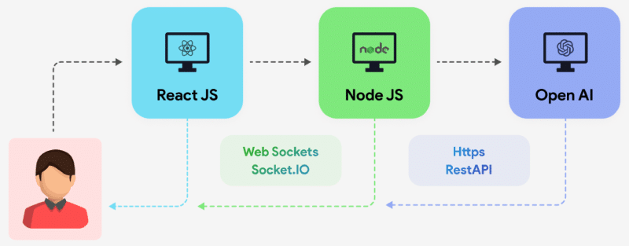

Fig 6.1 Integration in Web development

### **6.2 AJAX and Fetch for Asynchronous Requests**

**AJAX (Asynchronous JavaScript and XML)** enables web pages to fetch data from a server without refreshing the page. While traditionally implemented using XMLHttpRequest, the modern **Fetch API** provides a cleaner and more powerful alternative:

* **AJAX**: Uses XMLHttpRequest for sending HTTP requests and processing responses.
* **Fetch API**: Simplifies making requests with promises, handling data formats like JSON.

Example with Fetch:

|  |
| --- |
| **fetch('https://api.example.com/data')**  **.then(response => response.json())**  **.then(data => console.log(data))**  **.catch(error => console.error('Error:', error));** |

These technologies are widely used for creating dynamic web applications, enabling features like live search, chat updates, and content loading.

### **6.3 JavaScript Frameworks (React, Angular, Vue)**

JavaScript frameworks are libraries that simplify web development by providing ready-to-use components and architectural patterns:

* **React**: A library focused on building user interfaces using components and a virtual DOM for efficient rendering. React promotes a declarative and component-based development style.
* **Angular**: A comprehensive framework by Google that supports MVC architecture, dependency injection, and a powerful templating system. It's ideal for large-scale applications.
* **Vue**: A lightweight and flexible framework combining the best features of React and Angular. Vue is simple to integrate and suits small to medium-sized applications. These frameworks help developers build complex web applications more efficiently by abstracting common tasks like DOM updates and state management.

### **6.4 Testing and Debugging JavaScript Code**

Testing and debugging are critical for ensuring the reliability and performance of JavaScript code:

* **Testing**: JavaScript testing can be done using frameworks like **Jest**, **Mocha**, or **Jasmine**. These tools allow for unit testing, integration testing, and end-to-end testing to validate the functionality of code components.
* **Debugging**: JavaScript debugging is often performed using browser developer tools. Features like breakpoints, console logging, and step-by-step code execution help identify and fix issues. Debugging tools like **Chrome DevTools** and **Node.js Debugger** make the process easier. Example of console debugging:

|  |
| --- |
| **console.log('Value:', variable);**  **console.error('Error:', error);** |

A combination of testing and debugging practices ensures the delivery of high-quality, error-free web applications.

**CHAPTER – 7**

**PROJECT:**

### **7.1 Music Listener**

#### **Objective**

To create an interactive music player that allows users to enjoy and control their music seamlessly.

#### **Features**

1. Play, pause, and skip tracks functionality.
2. Browse and select songs from a playlist or library.
3. Volume control and mute options.
4. User-friendly and responsive interface for compatibility across devices.

#### **Technologies Used**

* **HTML/CSS**: For structuring and styling the interface.
* **JavaScript**: For implementing music player controls and interactivity.
* **Custom Media Files/Audio API**: To stream or play music.

#### **Key Learnings**

1. Working with JavaScript to manipulate media elements.
2. Creating an engaging and responsive user interface.
3. 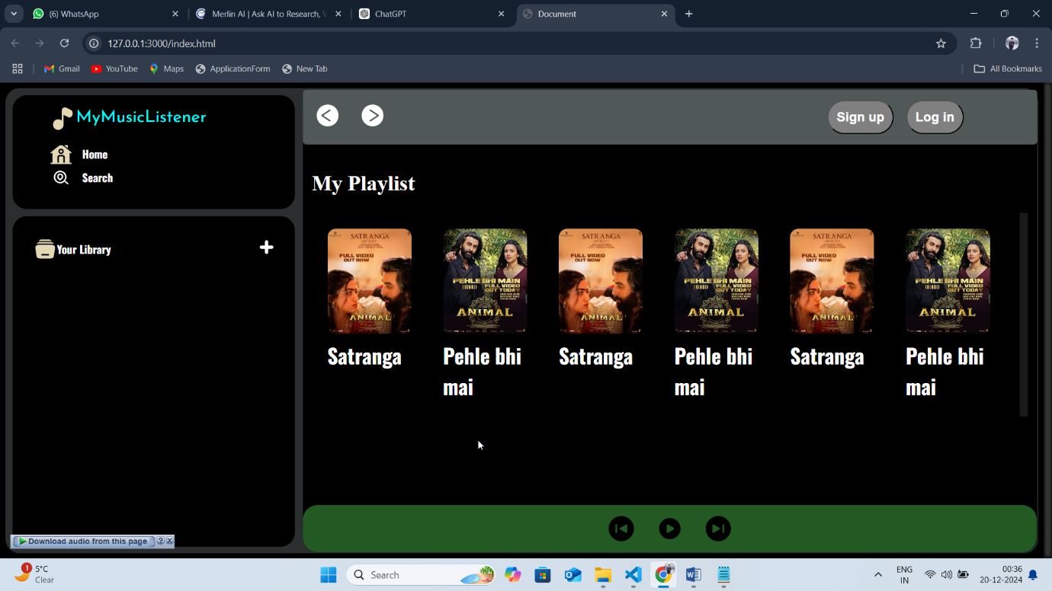Understanding user interaction with media controls.

Fig.7.1 Snapshot of Music Listener

**7.2 Weather App**

**Objective**

To provide users with real-time weather updates based on their location or a searched city.

**Features**

1. Display of current weather conditions, including temperature, humidity, and wind speed.
2. Integration of dynamic backgrounds based on the weather (e.g., sunny, rainy, snowy).
3. Search functionality for city-based weather updates.
4. Real-time data fetching from a weather API.

**Technologies Used**

* HTML/CSS: For UI design and styling.
* JavaScript: For fetching data and updating the DOM.
* Weather API: Such as OpenWeatherMap API for real-time weather information.

**Key Learnings**

1. Utilizing APIs for fetching and processing real-time data.
2. Managing asynchronous operations with JavaScript (e.g., Fetch API).
3. 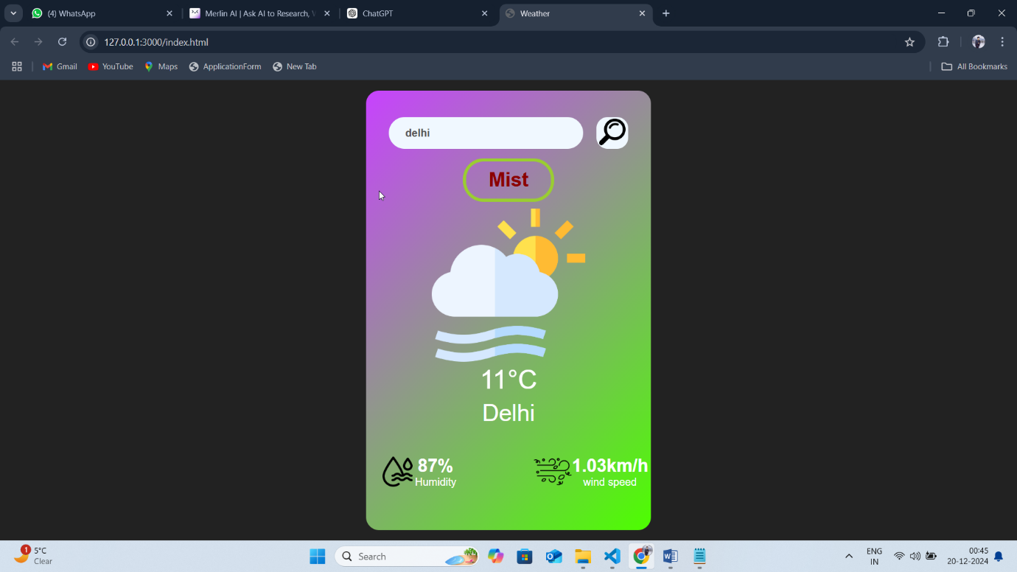Enhancing user experience with dynamic and responsive design.

Fig.7.2 Snapshot of Weather App

**CONCLUSION:**

The early chapters covered essential topics such as variables, operators, control structures, and functions, laying a strong foundation for understanding how JavaScript operates. Advanced concepts like closures, modules, and functional programming demonstrated the language's depth and its ability to handle complex programming paradigms.

The discussion on asynchronous JavaScript, including callbacks, promises, and async/await, highlighted the language's capability to manage non-blocking, real-time operations efficiently. The integration of JavaScript with the Document Object Model (DOM) illustrated how developers can create engaging user interfaces and handle events dynamically.

Finally, the application of JavaScript in real-world scenarios, such as integrating with HTML and CSS, working with APIs for AJAX and Fetch, and utilizing modern frameworks like React, Angular, and Vue, emphasized its relevance in building robust web applications. The focus on testing and debugging reinforced the importance of writing reliable and maintainable code.

In conclusion, JavaScript serves as a cornerstone of modern web development. Its vast ecosystem, combined with its ability to integrate seamlessly with other technologies, makes it indispensable for building everything from simple scripts to complex applications. This report not only demonstrates the breadth of JavaScript but also encourages further exploration and mastery of its capabilities to meet evolving technological demands.

**REFERENCES:**

• **Mozilla Developer Network (MDN). (n.d.).** JavaScript Functions. Retrieved from <https://developer.mozilla.org/en-US/docs/Web/JavaScript/Guide/Functions>

• **GeeksforGeeks. (n.d.).** JavaScript Array Methods. Retrieved from https://www.geeksforgeeks.org/javascript-array-methods/

• **Mozilla Developer Network (MDN). (n.d.).** JavaScript Promises. Retrieved from <https://developer.mozilla.org/en-US/docs/Web/JavaScript/Guide/Using_promises>

• **GeeksforGeeks. (n.d.).** Understanding JavaScript Closures. Retrieved from https://www.geeksforgeeks.org/javascript-closures/

• **Mozilla Developer Network (MDN). (n.d.).** Asynchronous Programming and Promises. Retrieved from <https://developer.mozilla.org/en-US/docs/Web/JavaScript/Guide/Asynchronous_Programming>